Name: Siddhesh Santosh Shinde
YSM Python Info Solution Internship 2025(Assignment no.2)
- Write a function greet(name) that takes a name which is store in variable as input and prints "Hello, [name]!".
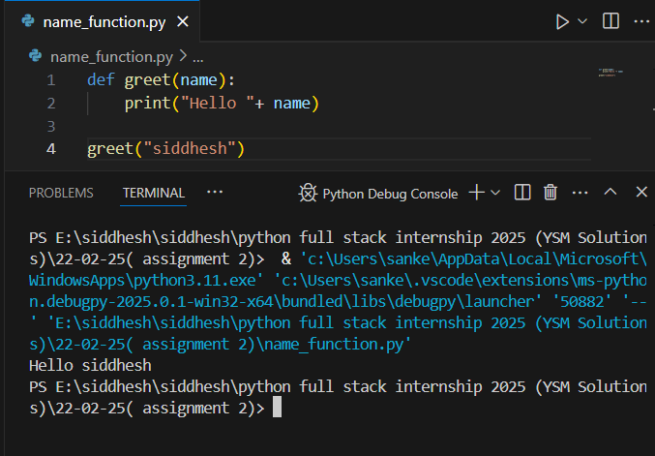
- Create a function square(num) that returns the square of a given number.
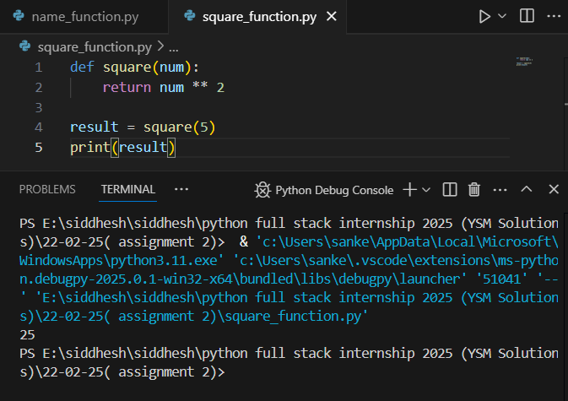

- Write a function is_even(n) that returns True if a number is even, otherwise False.
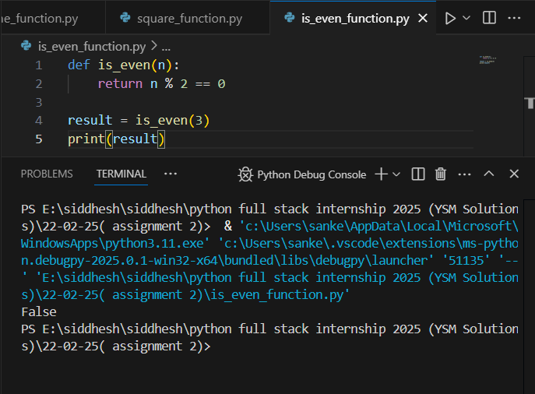
- Define a function sum_numbers(a, b=10) that takes two numbers and returns their sum. If the second number is not provided, it should default to 10.
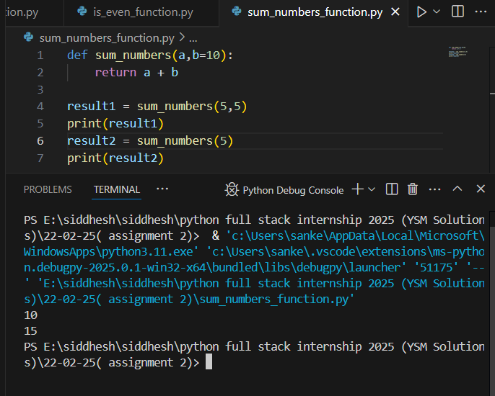

- Write a recursive function factorial(n) to calculate the factorial of a number.
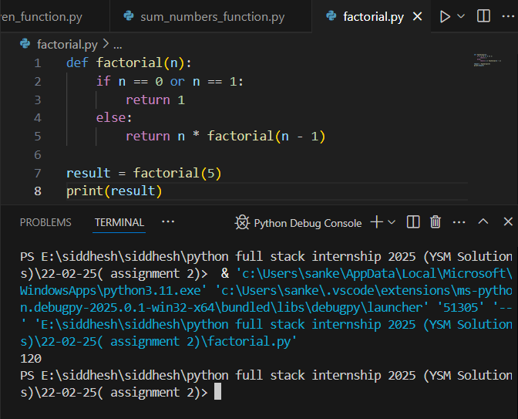
- Use a lambda function with filter( ) to get all even numbers from a list: [1, 2, 3, 4, 5, 6, 7, 8].
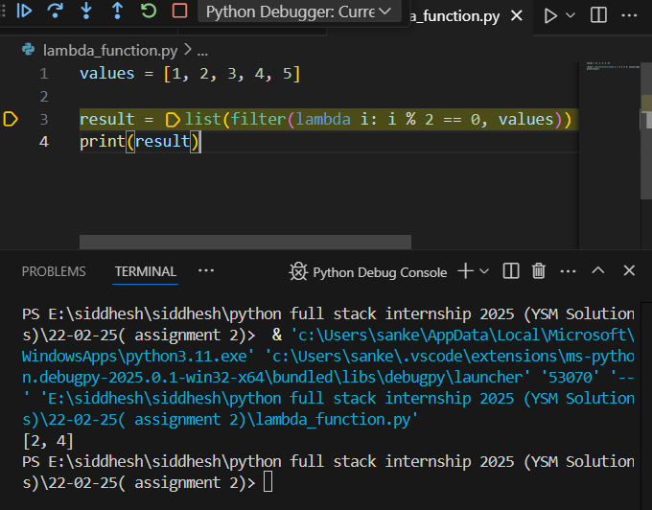
- Write a while loop to print the first 5 multiples of 3.
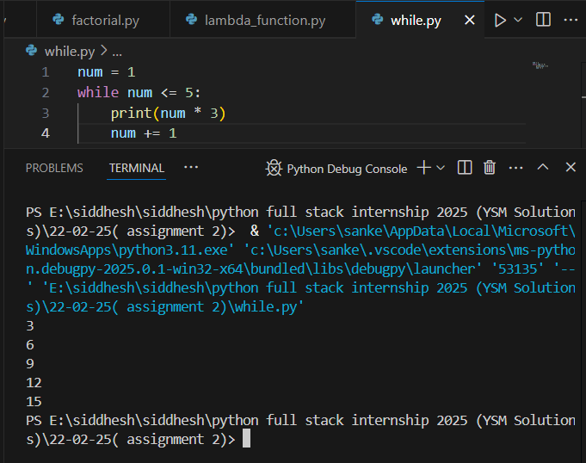
- Create a loop that prints all numbers from 1 to 20 but skips multiples of 5.
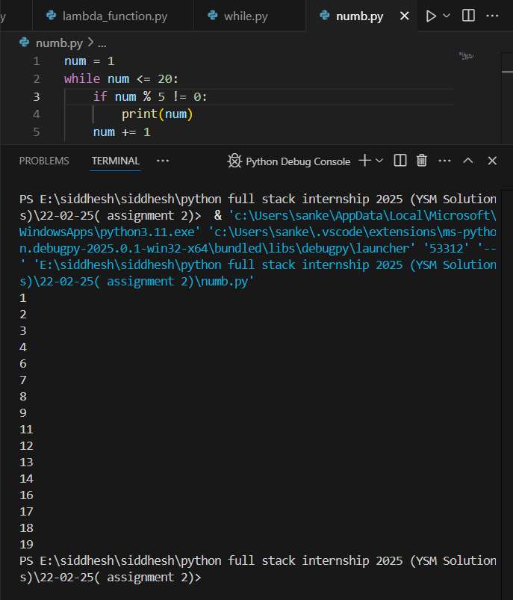
- Write a loop that stops when it encounters the number 7 in this list: [1, 2, 3, 4, 5, 6, 7, 8, 9].
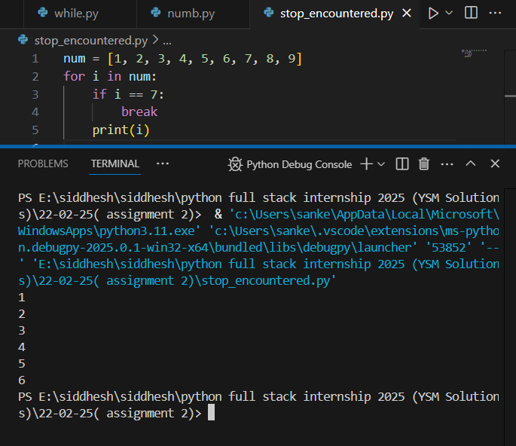
- Write a program that checks if a year is a leap year. (Hint: A year is a leap year if it is divisible by 4 but not by 100, except when it is also divisible by 400.)
